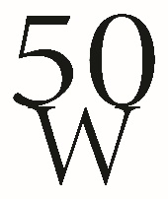
Now accepting inaugural member applications. To become a part of 50 Women Gulf Coast, fill out the application below. Please consider a 5-year promise to the organization which would ensure $250,000 for Gulf Coast non-profits over the next five years. We anticipate a waiting list as we have several women already committed. Don’t delay, membership is filled upon receipt of payment.
Send your tax-deductible donation check for $1,020 endorsed to Bacot Foundation of South Mississippi to:
Bacot Foundation of South Mississippi
PO Box 1442
Pascagoula, MS 39567
*Please memo 50W on your check.
If you would like to pay by credit card (extra fee) contact Teri Freitas (228) 369-0251.
□ Yes, I would like to make a five-year pledge to 50 Women Gulf Coast.
□ I would like to only make a one-time commitment of $1020.
□ I am not interested in helping the MS Gulf Coast with nonprofits at this time.
Name: _______________________________________________________________
Cell Number: ____________________ Email: ______________________________
Address: ______________________________ ______________________________
Brief Bio: _______________________________________________________________________________________________________________________________________________________________________________________________________________________________________________________________________________________________

□ Check if you would like an emailed receipt. Office use:
Date received __________

